AI-Integrated Wearable Device for Thermal Regulation and Survival in Extreme Cold Environments

A. Ankitha K N and B. Ashwini D M

***[1] [2] Abstract Here we report on the design and development of artificial intelligence integrated wearable device for adaptive thermal regulation in extreme cold environments to enhance the survival capabilities. By using state-of-the-art thermoelectric materials, alongside smart algorithms, the system measures and regulates body temperature in real-time. And can come with energy-efficient features or be portable and IoT-enabled for remote access and monitoring. AI also helps to integrate personal thermal control with other relevant information, such as environmental and physiological data. Use ranges from military in austere. Applications range from military use in harsh terrains to supporting mountaineers and researchers in subzero conditions.***

***Index Terms*—** **Adaptive thermal regulation, AI-enabled wearables, energy-efficient heating, extreme cold environments, intelligent survival systems, IoT in wearable devices, smart materials, thermoelectric technology, wearable thermal management.**

# I. INTRODUCTION

Staying in extreme cold is very much risky to lives due to the aspects of hypothermia, frostbite and low level of activity. Such conditions are normal for the military, particularly those who serve in the mountainous regions, climbers, scientists, and other enthusiasts of those regions, and people who make up Arctic and Antarctic journeys. Simple forms of insulation such as putting on many layers of clothing or hot chemical packs are in efficient not only in conditions that concern dynamic or exposed periods of time but flexibility as well.

Wearable technology PAI is a new way of addressing these challenges. Using real-time physiological and environmental information, AI can facilitate the temperature control in wearables making them more comfortable and safe to wear. Advanced thermoelectric materials, Internet of Things connection, energy-saving optimization have been primarily useful for tiny, transportable systems for harsh environments.

Related technology for wearable devices has come a long ways that delivers the right combination of functions, portability and comfort for the user. This has evolved to the current gadgets that not only capture the physical activity of an individual and their general wellbeing but are part of life. As one of the two key demands that have been driving wearable technologies even today, energy consumptions and the issue of heat

dissipation remain prevalent. The traditional battery powered wearable devices have a limited operational period, and are mostly required to be recharged or replaced often, which is quite inconvenient for the users. In this respect energy harvesting technologies like TEGs has been discussed as promising approaches for operating wearable devices. These systems employ the Seebeck effect which is an electrical technique that is used to transform the differential in thermal potential between an object and its surroundings with specific reference to the human body. This kind of strategy can provide a way to design fully self-sufficient batteries incorporated wearable electronic devices that can continue to work continuously using body heat as a dominant power source.

Wearable technology has come a long way in its development it has brought an almost perfect blend of utility along with mobility to the user. This process has endorsed to machines that allow the tracking of the physical activity as well as the overall fitness and wellness of a person, integrated into society assets. This is one of the main consideration areas that are still being driven hard and forcing advances in wearable devices, namely energy usage and thermal management.

The traditional Battery driven wearable device devices have a fixed period and are frequently required to be recharged or replaced that is rather uncomfortable for the users. Consequently, such technologies as TEGs has been evaluated as promising solutions for energy supply of wearable devices. These systems employ the Seebeck Effect which is a technique of converting the differences in temperature between the human body and the person into Electrical current. This approach also has the potential for creating new, completely self sufficient battery integrated wearable devices that would be able to continuously operate as one of the major power sources is body heat One of the biggest challenges when considering thin and flexible wearable technologies which may be used for continuously like wrist watches or health trackers is the thermal management problem. Since these devices are constantly on, they emit heat and where proper thermal management is not provided, the user feels uncomfortable or even harmed. Of most importance in this regard are devices that are likely to come into contact with the skin regularly because when the skin gets hot, a person may develop rashes or even burns. The proposed application brief identified heat dissipation as critical in preventing heat generation that is fatal in advanced wearable devices that use more power in the future- thermal management should be properly integrated in wearable devices. Sophisticated features, for example, in thermal management materials, heat dissipation structures, and cooling systems are adopted in wearables to work extra hard and eliminate heat.

Also, the smart wearable devices incorporating IoT and thermal systems are one of the emerging solutions of environmental and health problems. For instance smart jackets that have both heating as well as cooling features can control the internal temperatures in confrontation with outside climatic conditions and provide necessary protection from unforgiving temperatures. These wearables do more than simply improve comfort, but can also offer real-time health check-up including pulse rate and temperature through the smartphones or buttons. Therefore, through implementing both adaptive thermal regulation and health monitoring system, the danger which may occur from wearing cloth under extreme weather conditions such as heat stoke or even cryogenic shock is overcome, making the wear able technology a great tool for survive.

Energy harvesting systems, effective thermals and health indicators incorporated in wearable technology devices are already changing the very fabric of personal electronics. These innovations are not only improving the usages of wearables but also, opening many new doors in various sectors like health, sports and environment. Greater levels of autonomy, adaptability, and incorporation into the lifestyle will be seen in subsequent wearables of the forthcoming years and while providing convenience, they will always ensure the safety of the wearer..

.

# II. TEG-Based Energy Harvesting Systems

Thermoelectric generators (TEGs) offer a groundbreaking solution for powering wearable devices by converting body heat into electricity through the Seebeck effect. This technology capitalizes on the natural temperature difference between the skin and the surrounding environment, which exists in most indoor and outdoor conditions. By harnessing this ubiquitous energy source, TEG-based systems aim to eliminate the reliance on traditional batteries, making wearable devices more sustainable and convenient for long-term use in diverse settings.

**1. Principles of TEG Operation**

A TEG comprises thermoelectric materials placed between two ceramic substrates. Part of the TEG, called hot side, touches with the skin, while cold side is attached to the heat sink. This arrangement makes it possible to have a temperature difference always, hence conversion into electrical power is feasible. The amount of voltage produced in a TEG is dependent on the temperature differential across its surfaces. Generally, voltages generated by wearable TEGs are in the range of millivolts. These are further boosted to usable levels (>=1V) by the integrated DC-DC converters to enable it power the downstream electronics.

TEG performance derives its measure from the ZT value, which is related to the thermal and electric conductivities of the material and the Seebeck’s coefficient. For instance, Bi2Te3 is one of the most common materials used in fabricating wearable TEGs because it provides good efficiency at moderate temperature gradients.

**2.Integration with Wearable Devices**

 One of the system topologies that are ideally suited for wearable devices utilizing thermoelectric energy harvesting from body heat is comparable to that shown in Figure 1. With a skin-worne TEG, the output voltage is always low <100 mV which is boosted to greater than or equal to 1 volt IC Compatible voltage levels through a DC-DC converter. The main point of this work is the electrical output power and voltage available of the TEG in S.

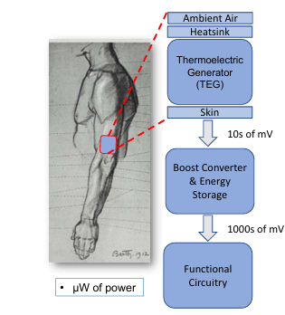

Fig. 1. A wearable device incorporates a thermoelectric generator (TEG) to power downstream functional circuitry. This work presents experimental measurements of skin-worn TEGs to determine continuously available output power and output voltage for battery-less wearable devices.

In order to evaluate achievable output power from the skin placed TEG, a TEG is applied onto the forearm of the user using modified elastic athletic band as depicted in Figure 2. In many cases in indoor space, the skin surface can be seen as the hot side of the TEG. The chosen TEG (Marlow TG12-6L, 40mm x 45mm) is bonded on its alternate side to a heatsink measuring the same contact surface dimension as that of the cold side of the TEG, which is an aluminum thermally conductive adhesive bus. Heat is removed passively via the air movement made feasible by the cutouts. This assembly of parts is held firmly in the band as a result of the pull from a strap that encircles the heatsink. The armband elasticity ensures the contact between the hot of the TEG and the user’s skin by tensioning.

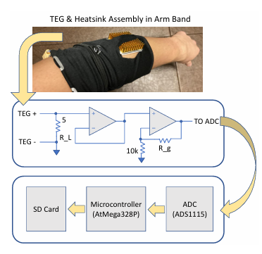

Fig. 2. Arm-worn TEG and measurement system architecture providing maximum power transfer and continuous data logging

In order to measure the electrical output the TEG was fitted to a passive resistive load and the voltage across the load was measured (Figure 2). In order to load the TEG output for maximal power transfer, a passive resistive load that was experimentally determined to be optimum is connected to the TEG output as indicated in Sec. II-B. The voltage across the load drives a voltage follower (LMC6032) which, in conjunction with measurement electronics powered from a separate source, serves to remove the TEG output from the measurement and thus avoids measurement losses. The voltage follower drives a non-inverting operational amplifier (LMC6032) having an adjustable gain and the output from the amplifier was measured with a 16 bit ADC (TI ADS1115) and the digitized data was transferred to an SD card through a microcontroller (AtMega328).

In a portable version of the system the power supply for the measurement electronics is provided by a 5VDC USB battery pack. To avoid excessive weight all the logging systems were housed in a separate shoulder pack and a two-conductor cable was used to connect everything to the armband TEG pack. The block diagram for the complete measurement system is shown in Figure 2.

**3. Challenges in TEG Implementation**

The use of TEGs in wearables has numerous hurdles notably concerning efficiency, miniaturization, and stability. Power density is usually low in such contexts since there are low temperature gradients (usually < 10°C). Research tasks involve seeking suitable materials that will result in TEG devices with ZT higher than one and developing proper TEG designs that will promote optimal thermal coupling.

The other key factor relates to the maintenance of temperature gradient across TEG surfaces. It requires an accurate design of heat sinks to prevent the cold side from heating too much. For wearable devices making use of PGS embedded silicone rubber, this usually entails using the lighter material. They allow better heat dispersal and even make the device more comfortable for the user by maintaining a soft and flexible shape.

**4. Advancements in Load Matching and Energy Management Methods**

To achieve the maximum performance of energy harvesting, load resistance of TEG should be matched to its internal resistance. Empirical experiments shown that it is possible to maximize power output by adjusting the load resistance and for wrist-worn TEG systems that is equal 5 Ω. The inclusion of energy storage systems like supercapacitors or small lithium-ion batteries provides constant power when there is no activity or low temperature gradient.

Advanced Power Management Circuits play an important role in Wearable PTEG systems, which stabilize output voltage and distribute power to critical parts of applications especially, on Internet of Things (IoT)-based devices where sensors, communication modules and data storage need electricity constantly even in dynamic environmental condition.  
  
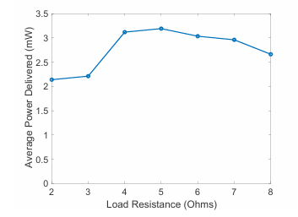

Fig. 3. Power delivered for varying load resistance is used to verify nominal TEG source resistance for load matching and maximum power transfer.

The Load Matching Experiment was performed in order to maximize power delivery from the TEG through modulating the load resistance to match the TEG source resistance. A temperature gradient of ∼10°C was created using hot-plate and heatsink with a fan. The load resistance was swept within measured bounds of 2Ω and 10Ω while monitoring power delivered. The max average power of 3.2mW occurred at 5Ω for this study, indicative also that the load matching technique is viable for skin-worn typical temperature gradients of a few degrees.

**6. Broader Applications and Future Potential**

Nevertheless, the primary use of TEGs is not only in wearables, but in medical, industrial, and environmental sensors. For example, TEGs can be incorporated into wearable health monitors where it generates real-time data of body vital rates without charging very often. Thus, where survival depends on equipment, TEG-powered wearables get important systems, for example, during polar or high-altitude operations.

The future of TEG technology in wearables lies in improving the scalability of power generation, advancing thermoelectric materials, and integrating AI algorithms for dynamic energy optimization. Emerging hybrid systems that combine TEGs with photovoltaic or piezoelectric energy harvesting technologies are also being explored, offering multifaceted solutions for powering next-generation wearables.

The opportunity of TEG technology in wearables will be in the ability to scale the technologies and develop more effective thermoelectric materials while employing AI for dynamic optimization algorithms. New hybrid systems are being proposed for further development that integrate TEGs with photovoltaic or piezoelectric energy scavenging technologies as potential wearables’ multifaceted power solutions for future wearable devices.

With TEG-based energy harvesting systems, wearable technology can be taken to the next level of innovation through energy-autonomous devices with enhanced capability. Considering these difficulties in material use, temperature control, and power utilization, these systems have the capability to transform the wearable market on uses in health, community, and technology.

# III. **Thermal Management Techniques for Wearables**

Wearable devices are continuously evolving, and therefore their technology evolves with life making it smarter and practical than before. They are wearable devices and in fact, second-skins of your smart, small companions with intuitive mechanical smart sensors; smart processors and smart applications communication integrated right into tiny wearable forms. Not only can it be helpful to picture them as small powerhouses of strength that are never far away but also always willing to rescue another person ; it can also be beneficial to imagine them as omniscient and capable of providing our helpful intercession at any one time horizontal height, and 3 mm for skin depth. We use a 25 degree C ambient temperature and a 32 degree C core temperature. Table I lists the parameters of the wrist model.

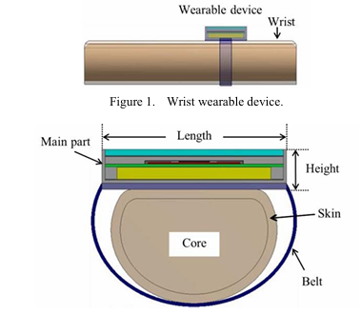

Figure 2. Wrist model.

TABLE I. BASIC PARAMETERS OF WRIST MODEL.

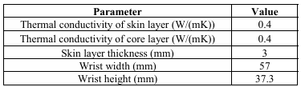

Fig. 3 shows the cross sectional structure of the main part of a device. The outline size is 35 mm wide, 60 mm long, and 11 mm high. Table II lists the thermal profile and dimensions of the main part. Fig. 4 shows the structure of 3D IC within the main part. The stacked chips consist of metal layers, device layers, Si layers, and micro bump layers. The thermal profile and dimensions are listed in Table III. The parameters are almost the same as [22, 23]. In the table, z axis corresponds to the direction of the height in Fig. 2

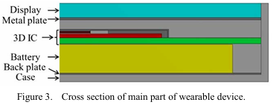

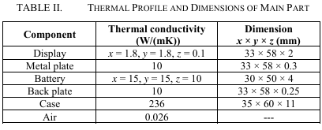

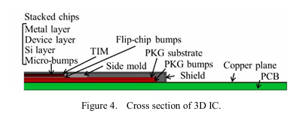

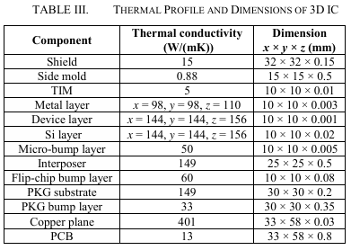

By and large, rubber belts are good uses for wristwatches and smartwatches. Of course, it is assumed that the material applied for the belt is the silicon rubber. The thermal conductivity is 0.2 W/(mK). Current wristwatches, the smartwatches primarily employ rubber belt in its mechanism. Table IV shows the parameters of the belt belonging to the scope of our study.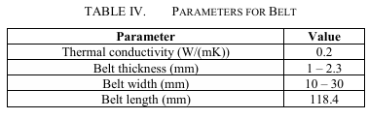

### **1. Thermal Challenges in Wearable Devices**

### Wearable gadgets are intended to be worn for long periods of time on the wrist, on the skin, and even on clothes, so the temperature of the gadget in most cases will be regulated by the body heat. This has the advantage of producing a continual supply of heat, which is a factor that may cause the system to overheat if it’s not well regulated. This is unlike handheld devices that are often raised in the air and can do away with the heat through the surfaces, wearables are in continual contact with the skin. It can also create increased heat within the unit that in turn has to be dealt with properly to avoid causing discomfort, failure or leading to skin damage. One of the major thermal controls for wearables is the trade-off between heat dissipation and device thin flexible and ergonomic form factors.

### **2. Thermal Management Strategies for Wearable Devices**

### Wearable devices use different approaches to regulate the heat produced by components of the device and these approaches may include; The use of inherent ‘passive’ approaches that involve use of simple material properties to cool the components, and the use of ‘active’ approaches that require separate power to cool the device. These strategies mostly depend on factors like power consumption by devices, size, type of environment and comfort level of users .

#### **A. Passive Thermal Management**

Primary passive thermal control strategies rely on the use of material that release heat or spread it evenly over the device. These solutions do not add extra power needs and are generally used most times in energy friendly wearables, since they do not complicate design by adding much weight or complexity.

A. 3D IC Relocation

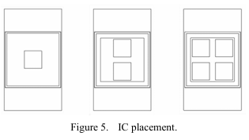

We assume that a 3D IC is used as a computing system in wrist wearable devices because it is effective for miniaturization. A 3D IC is usually put in one place without an interposer. As power density in the vertical direction increases, temperature increases [23]. Therefore, we propose arranging stacked chips on multiple locations horizontally. A 2.5D IC differs in how multiple stacked chips are placed. Fig. 5 shows an example when stacked chips are put on one, two, and four placements.

**1.Heat Spreaders and Heat Sinks** Heat spreaders are necessary to manage heat generated by one or several hot parts, for example, processors or batteries, within the permissible thermal range of the whole device. These spreaders are usually made from metals that have good thermal conductivity as copper or aluminum. Heat spreaders in wrist worn devices are sometimes integrated within the structure of the device or located immediately below or behind components such as microprocessors with a view of transferring heat out of the interior of the device and onto the outer surface of the device where it can be emitted to the surroundings.

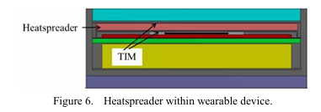

Heat sinks are other key passive thermal management techniques, especially for wearables that often incorporate high power consumption elements of wireless link modules or sensors. Heat sinks have to offer more surface area then the original device in order to expedite the rate of heat egress. Thus, thin and flexible metal sheets or mesh heat sinks are sometimes built into the outer shell of the device, or the wristband, and provide for efficient heat exchange without massive dimensions. In wearable technology, aluminum or copper alloy is preferred as a heat sink due to its lightweight to provide the optimum and comfortable temperature for the use of the technology and the gadget.

2.**Pyrolytic Graphite Sheets (PGS)** One of the relatively newer ideas in the field of passive thermal control for wearable devices is the use of PGS that includes high TCP in-plane. PGS can be recommended as one of the best materials for producing wearable devices since it is both flexible and has high thermal dissipation efficiency. The PGS sheets are placed inside the belt or the wristband of wearables to avoid generation of hot spots that may cause irritation or discomfort to the skin. Additionally, PGS is light-weighted, this is because wearing devices are expected to have the ergonomic design.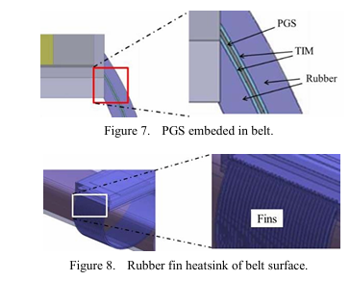

**3.Thermal Interface Materials (TIM)** In wearable electronics, thermal interface materials (TIMs) are used to enhance the thermal connection between the components and heat spreaders or heat sinks. These materials, often composed of silicone or graphite-based compounds, are particularly useful in filling gaps between irregularly shaped surfaces, improving thermal contact. By ensuring better heat conduction, TIMs enhance the overall thermal management of wearable devices without adding significant weight or reducing flexibility.

**B. Active Thermal Management**

**However, as the mentioned above, passive methods can be employed for many wearable devices but active thermal management can be used when the heat load is higher or when accurate temperature control is needed.. Active systems normally have part that requires power to run but have better airflow especially for high end devices.**

**1.Thermoelectric Coolers TECs or Peltier modules are an active cooling technique that utilizes the thermoelectric capabilities of Peltier effect to bring about difference in temperate through two distinct materials. Such a setup is made of two materials that, when an electric current is passed through the junction, heat from one side is transferred to the other side, effectively cooling the one and heating the other. This cooler type can work well for high-stress smart clothes, including smart clothes with instantaneous processors and health status indicators that may produce large amounts of heat. TECs can be incorporated into the said device, or they can be directly applied on the hot areas of a system so the temperature goes down and conforms to safe working conditions. However, TECs need more power to operate than coolers, which means the solution can be effective only if used with power management systems preventing battery consumption.**

**2.Micro Fans and Active Air Circulation** Small low power fans mounted into wearable devices can play an active role in fanning to boost heat exchange. These fans are generally used in stronger wearable application like smart jackets or fitness Trackers as these applications generate more heat due to continuous use or environment. It is aided by fans that bring fresh air round the device and also enhances heat transfer between the outer surface and the surrounding air. These micro fans are slightly thicker than traditional fans, but they do contribute a lot to the thermal comfort of the users, especially for wearables, which generate a lot of heat while exercising.

Heat Pipes In more demanding wearables where high operational thermal load is a necessity they can incorporate heat pipes to transfer heat consequently through the device. Heat pipes simply consist of a small amount of this liquid confined in a sealed tube; when the unit is heated, the liquid vaporizes and travels to cooler parts of the device; there it condenses and releases heat. These devices provide a high efficiency for heat control and are applied in application with high power demands or working in hot environments such as wearable devices.

**3. Considerations for Thermal Management in Wearables**

The design of wearable devices must account for several key factors in thermal management to ensure both efficiency and user comfort.

**1.Power Consumption and Heat Generation** With the increase in sophistication of wearable technology, device which may have one or more sensor, processor(s), and commutation module(s) that are by intrinsic function prone to generate heat. Health monitors with sensors or processors or wireless enhancing capabilities must have a steady supply of power uninterrupted. Consumption of Low power chips, Low power Controllers, motors and other sort of active or passive components needed for energy harvesting systems such as TEGs etc., are crucial in reducing heat output. When integrated with these advances in thermal control, these solutions make wearables operable for extended durations.

**2.Form Factor and Flexibility** Due to wearable functionalities, wearables must be thermal-cooler while designing wearables, they much also be small, light and flexible. Heat sinks, fans, and thermal interfaces must be incorporated without increasing the size of the Multimedia Computer and without greatly limiting this flexibility. So, adaptable and slender forms are employed in wearable designs so that a person wearing such outfit would not overheated and the item would be not too thick at the same time. This is especially so for products such as wrist worn fitness bands which have to fit the contours of the wrist and not be uncomfortable or hamper movement in the slightest.

**3.Environmental Influence** Thermal management system is effective in determining the external environment. Wearable devices deployed in high-temperature zones and extremely cold areas require thermal control techniques. Sporting equipments used during activities or productions for instance outside environment or particular sports, may use adaptive cool or heat functions to regulate temperatures of internal surfaces. For example, a smart jacket although may employ material containing Peltier modules that cool the body in hot environments or warm in cold.

**4. Future Directions**

#### As wearable technology products become more sophisticated, so will the thermal management solutions that underpin them. It can be expected that continued research in thermally conductive polymers and its composites would result in one or all of the above – efficiency, lightweight and flexibility in the design of heat dissipation systems. Similarly, the ideas of applying AI algorithms to thermal management systems can enable wearables to control their entire cooling and heating processes depending on real-time data and make them more comfortable and energy-efficient at the same time. Further development in wearables environments will create wearable devices capable of providing the best safe operating temperature environment regardless of conditions.

#### IV. Smart Thermal Jacket with Wearable Sensors using IoT

Thermal control in smart wearable applications is another key element in the optimization of function and protection of the user in harsh climates. This paper states that unlike normal thermal environments, wearable devices operate in harsh conditions such as high heat, low temperatures or unstable weather, and therefore require changeable interior temperatures to ensure the wellbeing and efficiency of the wearer. Adaptive climate control – smart systems that can adapt to the climate of the environment and individual climate control – has helped create wearable technology for survivalism and health for extreme environments. Such systems rely on buttons, temperature receptors, heating and cooling methods, and AI algorithm for responsive heating or cooling methods.

The concept of “Smart Thermal Jacket with Wearable Sensors using IoT” is a multi-functional system suitable for stressed and varying weather conditions. With a view of instilling climate control of internal space depending on the prevailing weather conditions, it incorporates both heating and cooling systems to deliver the best user comfort. It also lets the wearer track their heart rate and even shows information on an LCD and a phone app. The system guards against hypothermia and heat stroke thus it is appropriate for harsh environments. It has heating pads, cool fans, and is connected with IoT to provide safety and flexibility for activities in various climate.

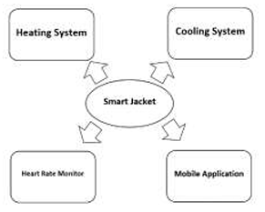

Fig.1. The above figure describes the basic concept of our proposed system

### **I. The Need for Smart Thermal Regulation**

The existing systems do offer heating, cooling systems only; however, the proposed system offers, we offers a heart rate monitor and mobile application which can be used to control the proposed system. The main function of the jacket is to mitigate on the effects that arise as a result of hot or cold conditions such as heat drop, heat stroke, heat rash, frost bite and hypothermia among others. Peltier integrated heating and cooling jacket has got heating and cooling using Peltier module, however it is limited in some way that cooling as well heating has to occur through Peltier which may take time.Refrigerator Jacket employs the Peltier module for the cooling as well as heating purpose; the issue with this invention is that it cannot be programmed through the application to adopt an appropriate temperature level.In the battery powered jacket use only one Peltier module for heating and cooling system and the controller used here is Atmega 16 whereas we have used Atmega 328.an be used to control the proposed system. The main moto of the jacket is to counter the health effects caused by hot and cold conditions such as heat stroke, heat rash, frostbite, hypothermia, and others. Peltier integrated heating and cooling jacket has got heating and cooling function using Peltier module, but it is restricted in certain way that cooling and heating has to happen through Peltier module so it’s a slow process which may consume time. Refrigerator Jacket uses Peltier module for cooling and heating function but the drawback here is that it cannot provide control to set the temperature manually through the mobile application. In the battery-powered jacket uses just a single Peltier module for heating and cooling system and they have used Atmega 16 but in our case, we have used Atmega 328. Temperature programmable suit utilises water circulation for cooling system in order to maintain the temperature. Adaptive Jacket has also only one microcontroller, Peltier module is used for heating and cooling system and temperature can not be controlled through a simple mobile application; there is no heart rate monitor. Smart suit measures temperature, pulse; it has a GPS chip, but no heating-cooling system is present. Smart Jacket of blood pressure measurement based in shape memory alloy is designed to have only one feature of measuring blood pressure of the user. Smart Vest and Helmet applying IoT for body temperature checking in body temperature exhaustion in athletes. Smart Jacket for Spinal Disc dislocation incorporates the use of a dc fan to regulate internal temperature for the patients.

I. BLOCK DIAGRAM This entire suggested idea is only related to Lilypad ATmega 328. The thermal and cooling process is achieved through using two various modules, where all the two serve different functions. The type of battery that powers the device is Lithium-Ion rechargeable battery is the power source. The components here are Lilypad temperature sensor, Heartbeat sensor, Wi-Fi module and the LCD. We have the temperature sensor for measuring the weather conditions and the heartbeat sensor that tracks the rate of the user’s heartbeat, both the results obtained are transmitted to the LCD screen. A Wi-Fi module is applied for the interaction with the microcontroller and the mobile application. Lilypad temperature sensor detects the temperature and delivers this data in analog format to ATmega 328 microcontroller. In the ATmega 328 microcontroller, the ADC regards the analog data as its input and then it quantises it. This temperature is then sent to the digital data which goes to the LCD module to complete the we have to use the Peltier Cooler module.

#### 

Fig.2. Block Diagram of suggested project

Heating and cooling circuits, as well as the jacket to which the mentioned power will be supplied, will be powered by a rechargeable battery. The system is able to be turned on/off by the presence of switch present in it. Well here, the Wi-Fi module is connected with main board called lily pad 328. The Wi-Fi is linked to a smartphone to a monitor of a jacket. The conceived mobile application also shows heart rate of the user. As for controlling heating and cooling systems our suggested project includes cooling system through Peltier module and heating system through heating pads and therefore our project is utterly different from others.

II. HARDWARE DESIGN

1.1 Lilypad ATmega328

Lilypad Arduino Atmega 328 is an Arduino programmed board developed for organizing electronic textiles. These can be joined seamlessly with wearable technologies can be attached to them. On its front panel, it consists of a 32 pin IC and can work at 2.2V – 5.5V voltage regulation. It has 14 pin for digital input/output (Among these, 6 are PWM output). Analog inputs are available in 6 pins. It has to be supplied with a current of 40mA Direct Current for every I/O pins granted. This Atmega328 has 16KB of on board flash memory.

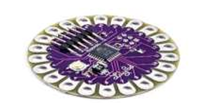

Fig.3. Lilypad ATmega328 is the microcontroller that has been used in our proposed system

#### 1.2 FTDI Breakout

*Working on a few examples Breakout In some instances, FTDI breakout is used to program the Lilypad when directly connected to it. Lilypad gets auto reset by the DTR pin when a new code is uploaded. There is jumper on the back of the board to allow it to be set to either 3.3V or 5V.*

Fig.4. FTDI Breakout is used to upload code to the microcontroller

#### 1.3 Wi-Fi Module

#### The ESP 8266 Wi-Fi Module ESP 8266 is a standalone Wi-Fi Sob which can add Wi-Fi connectivity to any other microcontroller. This Wi-Fi module serves as a link between the microcontroller and the mobile application and both of them can exchange information.

Fig.5. Wi-Fi Module ESP-8266 is the component which enables the micro controller to be controlled via mobile application

*1.4. Lilypad Li power*

*First of all, it is exceedingly compact and possesses substantial protection against development of short circuits. The board is specifically constructed and self assembled, to be as small and unobtrusive as possible. The special thing about Li Power is that it’s possible to use rechargeable batteries. The Lithium Polymer batteries are battery that can be recharged or recycled. These batteries are compact, slim, and these long-lasting batteries will last longer than an AAA battery.*

*1.5. Lithium-Ion battery*

*These are very small, very lightweight batteries and made up of Lithium-Ion. In producing 1000mAh every cell produces an output of 3.7V, Voltage . 3.5. Lilypad temperature sensor Basically, it senses changes in the atmosphere meaning temperature changes in the surrounding environment. It can sense from a range of -40°C being the lowest to +125°C being the highest.*

*1.6. LCD Display*

*Liquid Crystal Display is an extensively used electronic display module due to its affordability, availability, and functionality. The LCD which has been used in this project is 16x2. It takes 32 crystals to show each character. The temperature sensed from the temperature sensor is then sent to the LCD module and the same thing applies to the heart rate from the heart rate sensor.*

1. 7.Pulse Sensor

A pulse sensor is a detector that measures the amount of variation in blood vessels when the heart ejects blood into circulation. In addition, the component that captures the pulse will be mounted to the chest section of the jacket.

1.8. Peltier Module

A Peltier cooling module is utilized for the cooling function in the jacket of the garment. The following are the available types of dust collectors and they come in all these sizes: It begins working as a cooler after some point of temperature is achieved. It mainly operates using Thermoelectric cooling through Peltier effect.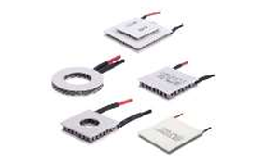

Fig.6. Peltier Module is used for cooling system

### 1.9. Heating Pad It is being used for the heating function of the jacket to attain a specific temperature in cold conditions. It can be controlled by a mobile application.

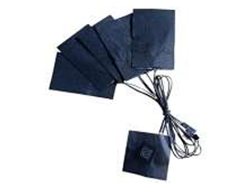

Fig.7. Heating Pad is used for heating system

III. WORKING PRINCIPLE

The Lilypad is controlled with the use of FTDI breakout as mentioned earlier while combining power of additional board. At first the required defining either for the whole code or for a mere function is initiated. As for the program flow The main loop of the code will consider the atmospheric temperature recorded by the temperature sensor as binary input. The Atmega 328 plays a role of converting the input data in to binary mode in to a decimal mode. Lilypad temperature sensor reads the temperature which is then shown on the LCD display. When the condition statement is true i.e., when the T_surrounding becomes greater than 30°C, the cooling process is commenced using the Peltier module through the heating or the cooling of two electric junctions through the conduction of heat. Then a voltage is applied over the connected conductors and thus generates an electricity current. Heating occurs at one junction and the cooling process is initiated at the same time, by the flow of current through the junctions of two conductors. In case the above stated condition is not true, the heating system gets switched on and the heating is carried out through heating pads which contains coils inside and heat at different levels depending on the selection of the user and the process goes on. With the help of Wi-Fi module, current temperature of the jacket is shown in the mobile application. The systems operate in parallel, it means if one heating and cooling system is on a technical stopper the other system performs effectively. The jacket can be dry cleaned I mean cleaning is also little bit easy in this jacket.

There are variety of microcontrollers available in market we are choosing Atmega 328 rather than other microcontroller for the following reasons: It has larger library function and coding friendly microcontroller It has storage space 328KB Furthermore Atmega 328 can able to integrate with the jacket over other microcontrollers.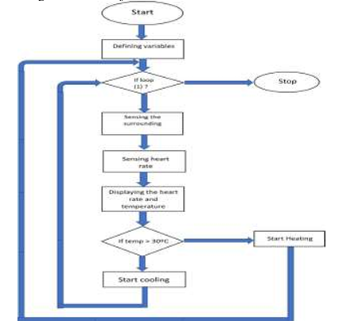

Fig.8. Flow Chart of the proposed system

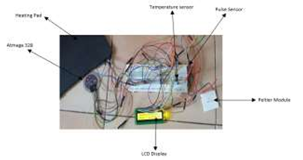

Fig.9. Circuit of the proposed system with the use of Atmega 328, LCD Display, Lilypad Temperature sensor, Peltier Module, Heating Pad

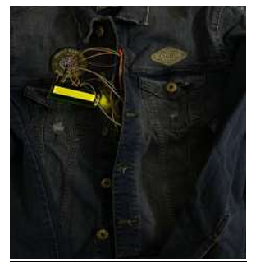

Fig.10. The Smart Jacket with the circuit implemented

### 

### Fig.11. Mobile Application which is used to control the jacket

### IV . RESULT

### The jacket is now complete with utilization of Peltier module, heating pads, Atmega 328, Wi-Fi module, Pulse sensor, Temperature Sensor, Rechargeable Battery. So, the user now can control his/her smart jacket with the help of a mobile application.

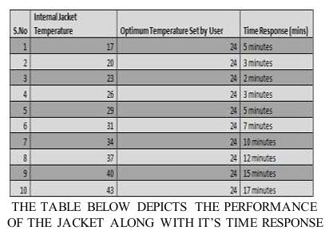

The application can be used to display temperature and heart rate and it also enables user to manually control temperature in his/her jacket. The peltier module is solely used for cooling purpose and the heating pad takes care of the heating process. So, in our suggested idea we are using peltier modules and a heating pad in various parts of the jacket as these components are placed in various parts it increases the efficiency drastically.

### **3. Applications of Smart Thermal Regulation Wearables**

Wearable smart thermal regulating devices are widely used in: health and military applications. Listed below are some of the most prominent use cases of wearables thermal regulation technology.

**Outdoors**: Needed to all outdoor workers, including soldiers, or anyone who must operate in a rather adverse environment, be it construction work, miners, or people stationed in the extreme climatic regions of the globe. They can prevent the dangers of heat exhaustion and hypothermia by having real-time dynamic regulation of temperatures.

**Sports and Fitness**: Smart thermal regulation wearables provide athletes and outdoor enthusiasts with gear that maintains their bodies in optimal temperature ranges during high-intensity activity. These wearable devices can monitor physiological parameters such as body temperature and heart rate to adjust heat dissipation or retention strategies based on the physiological parameters observed.

**Medical Applications**: Because the device is able to regulate, for patients using these devices, it may help health by a person having multiple sclerosis or some form of circulatory order. It can even moderate body temperatures to help avoid heat strokes, or merely serve for comfort as related to whatever form of medical procedures involved.

**Disaster Relief and Extreme**: Sports Wearable thermal regulation systems are used in extreme sports like mountaineering or polar expeditions to avoid fatal temperature variations. These wearables can dynamically control temperature changes and prevent hypothermia and overheating, thereby increasing safety and high performance in extreme conditions.

### **4. Future Directions in Smart Thermal Regulation**

The evolution of smart thermal control on wearable devices is analyzed to incorporate further enhancement of AI or machine learning. These systems will be able to learn constantly the environmental conditions and the physiological parameters of the wearer to regulate fashion temperature in real time bases. Moreover, changes in material properties at the material science level like more efficient thermoelectric materials or the second generation PCMs will enhance the effectiveness of the wearable thermal management systems .

The combination of multi- Modal energy harvesting solutions like thermo electric and piezo electric also make ‘wearables’ function as a never-ending battery. This will prove very useful in areas that do not or cannot have external electric power supply and other harsh areas. Finally, the aim is to develop smart textiles targeted at temperature modulation as well as wearables that are energy autonomous, or more efficiently, energy-optimizing.

Thus, the usage of smart thermal regulation systems in wearable technologies holds key to changing people’s experience and their interaction with the environment, particularly in conditions of high or low temperatures. Through incorporating thermoelectric coolers, phase change materials and real time sensors into these devices, users will be offered comfort and protection in various harsh working conditions.

V. Experimental results and analysis

### Smart thermal regulation system for wearable electronics application can only be judged by real-time experimentations designing wearable devices. Suite an experiment of the RP SOI might address issues such as; efficacy of thermal control strategies; power yield of energy harvesting; or adaptive cooling/heating strategies. The analysis of such results gives an understanding of the feasibility of using these devices in extended conditions, using comfort, safety and sustainability as selection criteria.

### **1. Experimental Setup for Thermal Management and Energy Harvesting**

Experimental setup means that the configurations allow imitating the actual use of wearables and assess the thermal management systems. One typical configuration for assessing TEG-based power scavenging requires a TEG to be placed on the skin where the released heat is then effectively removed by a heat sink. It is worn at the forearm or wrist where body temperatures and the surrounding environment are favorable. Thus, the power output of the TEG is recorded under varying circumstances, such as varying ambient temperatures, skin contact time.

The experimental methods were based upon assessment of the output power of a TEG worn on the skin. Silent subjects had a TEG arm band with a shoulder pack for up to four hours where the device was worn over the left arm near the elbow. The test consisted of “cold start” and “hot start” s and each of these s were for sixty minutes. Measurements were done at a frequency of 1Hz, with voltage recorded to allow characterisation of the TEG upon application of the hot side and after thermal stabilisation. Test subjects utilized clothing that exposed the heatsink to the environment for the conduction’s period of time.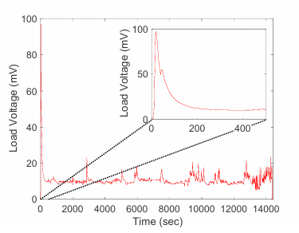

Fig. 4. Measured raw load voltage generated during a continuous 4-hour experiment with the arm-worn TEG and measurement device.

### **2. Experimental Setup for** Future Wrist Wearable Devices

We also confirmed our proposed thermal management methods with 3D finite element method thermal simulation. The steady-state maximum temperature was mainly noticed at the ICs, and the analysis parameters are discussed in Table V. Fig. 9 shows the effects of distributing chips in multiple positions of a 3D IC [as shown in figure 5] where, herein placements of one, two, three and four have reduced the maximum temperature to 46.6°C from 48.4°C. Fig. 10 presents the heatspreader case, where the size of heatspreader in question was increased from 12 × 12 mm to 32 × 32 mm; and there, the increase in heatspreader size reduced the maximum temperature considerably.

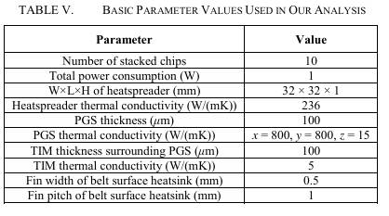

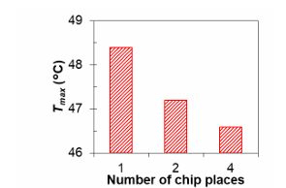

Figure 9. Effect of number of chip places.

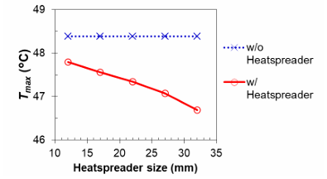

Figure 10. Effect of heatspreader within wearable device.

As illustrated in Fig. 11, there was interference when the PGS was embedded in belt rubber, as shown in Fig. 7. From these results it is observed that as the belt width increases, the maximum temperature decreases. At the belt width of 0.3 m=30mm, the belt-in PGS heated up to a maximum temperature of 43.9°C. Likewise, the influence of belt surface rubber fin heatsinks is presented in Fig. 12, which is illustrated in Fig. 8. When the belt width was 30mm, the maximum temperature of the belt surface fins integrated with a PGS decreased to 42.3°C.

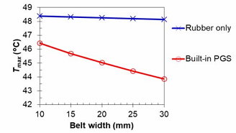

Figure 11. Effect of PGS embedded in belt.

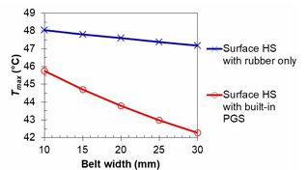

Figure 12. Effect of belt suface heatsink.

Table VI highlights temperature reduction achieved through various methods at 1 W power consumption. For instance, temperature rise in non-measures is 16.4°C, while with all measures, it’s 7.7°C, achieving a 53% reduction. Parallelization, heatspreaders, and PGS-embedded belts effectively reduced temperatures, with belt-based thermal management showing notable performance.

Figs. 13–16 demonstrate steady-state behavior, gradients, and improvements. Table VII summarizes temperature reductions in all parts. The proposed methods, tested on a 35 × 60 × 11 mm wearable shape, are applicable to devices of varying sizes and shapes, including watches.

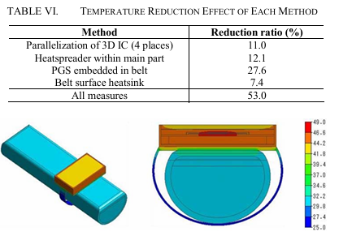

Figure 13. Temperature distribution before thermal management.

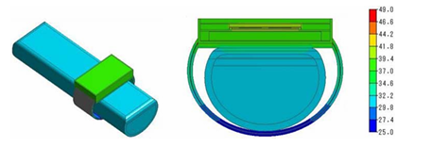

Figure 14. Temperature distrubution after thermal management.

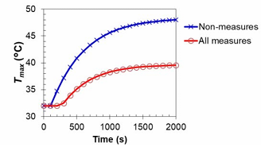

Figure 15. Transient thermal response.

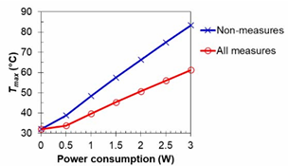

Figure 16. Effect of proposed methods (all measures).

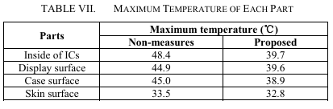

### **3. Adaptive Thermal Regulation and User Comfort**

### A major portion of smart wearables has integrated with thermal control systems that enable tracking environmental data and the physiological status of the user to control the thermal management system adaptively. The above devices incorporates Intelligent systems that monitor body temperatures, sweating, and even heart rates so that they can easily predict the changing conditions.

### **Real-Time Data Analysis**

### Some experimentation proves that wearables incorporating sensor technology can capture the user’s thermal status and control the heating or cooling systems of the device in real-time. For example, in interaction with physical activity, if the temperature is high, thereby increasing body temperature, then built-in coolers will turn on. On the other hand, in cold climates heating elements, can be switched on to help regulate the temperature, making the environment warm thus improving comfort rather than contracting conditions such as frost bite or hypothermia.

### **AI-Driven Adaptive Systems**

### By now the AI algorithms are incorporated to the wearables so as to enhance the thermal management. Through the study of characteristics inherent in body data, as well as the surrounding atmosphere, artificial intelligence algorithms can estimate the time the body will require cooling or heating and change the temperature of a device before the discomfort sensation. For instance, a wearable with an AI-based system can notice the initial symptoms like increased pulse rate or raised temperature rate of sweating, that leads to heat exhaustion and then prevent it by cooling the body so as to prevent heat stroke. It is essential to understand that AI integrated wearables can thus help give a more tailored approach by being able to factor in the thermal inclinations of the wearer as well as overall external climate.

### 

### **4. Analysis of Power Consumption and Thermal Efficiency**

### Energy consumption and thermal management are important factors often influencing wearable devices. The collected experimental data indicate that combining both passive and active thermal management solutions can enhance total efficiency with modest influence on power usage. For example in wearables which have thermoelectric cooling coupled with passive heat spreader the power consumption is low but the cooling is sufficient.

### **5. Results and Insights from Real-World Applications**

#### Outdoor athletics or military training environments of wearable devices show that the thermal management systems work in real life. In such events, wearables with the integrated thermoregulation capacity can perform amphibious dynamic adjustments to the external temperatures to keep the user comfortable without getting a heat or cold stroke. For instance, wearables that soldiers employ in hot environments were capable of providing coolness to the body besides consuming a small amount of power to make it possible for it to work for an extended period before it is recharged.

#### Conversely, smart thermal jackets worn during extremely low temperatures exhibited considerable potential in terms of improvement. These jackets were able to adapt to the cold and decrease the rate at which heat is lost to the surroundings so that the users do not develop hypothermia while, at the same time helping to minimize energy usage. The presence mentioned above use cases show that wearables have the potential to enhance the safety and convenience of subjects across various settings.

#### Therefore, it can be determined from the experimental findings that effective thermal control and energy collection strategies should be incorporated into converging wearable technologies that must have long-term usability and affordability in harsh conditions. These outcomes may serve as a valuable reference for approaching the question of how power consumption, temperature control, and comfort of the skin may be most effectively achieved in the future smart, self-sufficient wearables.

#### **VI. CONCLUSION**

This paper focuses on harvesting body heat energy for running wearable devices through thermoelectric generators and evaluates the techniques for thermal control of wrist-worn gadgets. The study shows that having a centimeter-scale TEG benefit from the body heat, one can generate power, 22.9 µW, which can run small low power devices, of practical use in battery-less wearables . In addition to energy harvesting, this paper provides an insight into thermal management approaches such as heatspreaders, PGS embedded belts, and chip parallelization, which shows considerable enhancements to temperature control of wearable electronics.

The Smart Thermal Jacket with IoT connected temperature control responds to cases of extreme climatic temperatures through the installation of an internal heating and cooling system. It also includes the monitoring of the rate of the heartbeat to ensure safety and comfort to those working in extreme conditions like construction people or the police.

Therefore, integrating energy harvesting techniques and innovative thermal control in wearable technologies not only encourages effective, homeostatic thermal regulation user comfort and energy efficiency but also allows for future technologies incorporating self-powering, autonomous systems. Further research in these fields will create the context for new generation wearable devices that can be applied under various climatic conditions and in a broad range of functional requirements.

VII. REFERENCES

[1] R. I. Smith and M. L. Johnston, "Analysis of skin-worn thermoelectric generators for body heat energy harvesting to power wearable devices," *Proceedings of the 2021 43rd Annual International Conference of the IEEE Engineering in Medicine & Biology Society (EMBC)*, Virtual Conference, Oct 31 - Nov 4, 2021.

[2] M. A. Manibabu, N. V. P., M. Vidhya Lakshmi, and A. Padmanaban, "Smart thermal jacket with wearable sensors using IoT," *Proceedings of the Sixth International Conference on Computing Methodologies and Communication (ICCMC 2022)*, IEEE Xplore, ISBN: 978-1-6654-1028-1, 2022.

[3] K. Matsuhashi and A. Kurokawa, "Thermal management for future wrist wearable devices," *Proceedings of the 3rd International Conference on Integrated Circuits and Microsystems*, 2018.

1.
2.